**DAILY ONLINE ACTIVITIES SUMMARY**

|  |  |  |  |  |  |  |  |  |
| --- | --- | --- | --- | --- | --- | --- | --- | --- |
| **Date:** | **29/05/2020** | | | | | **Name:** | **POOJA D S** | |
| **Sem & Sec** | **4th SEM 'B' Section** | | | | | **USN:** | **4AL18CS056** | |
| **Online Test Summary** | | | | | | | | |
| **Subject** | | **Operating System** | | | | | | |
| **Max. Marks** | | **30** | | **Score** | | | **26** | |
| **Certification Course Summary** | | | | | | | | |
| **Course** | **1.Cloud Foundations**  **2.Introduction to Digital Marketing** | | | | | | | |
| **Certificate Provider** | | | **Great Learning Academy** | | **Duration** | | | **1. 4.5 hour**  **2.5 hour** |
| **Coding Challenges** | | | | | | | | |
| **Problem Statement:** A user will input two strings, and we find if one of the strings is a sub sequence of the other. Program prints “yes” if either the first string is a sub sequence of the second string or the second string is a sub sequence of the first string. Assume that, the length of the first string is smaller than or equal to the length of the second string. Assume that, the length of the first string is smaller than or equal to the length of the second string. | | | | | | | | |
| **Status: completed** | | | | | | | | |
| **Uploaded the report in Github** | | | | | **yes** | | | |
| **If yes Repository name** | | | | | <https://github.com/dspooja/C-coding>  <https://github.com/dspooja/Java-coding> | | | |
| **Uploaded the report in slack** | | | | | **yes** | | | |

Online Test Details: (Attach the snapshot and briefly write the report for the same)

Certification Course Details: (Attach the snapshot and briefly write the report for the same)

Coding Challenges Details: (Attach the snapshot and briefly write the report for the same)

ONLINE TEST DETAILS:

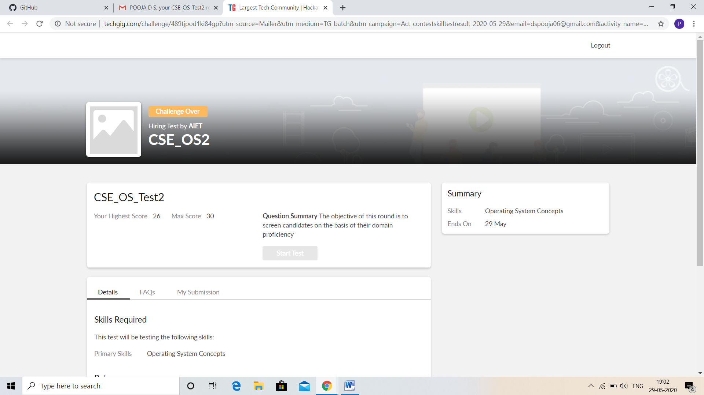

CERTIFICATION COURSE DETAILS:

* As continuation of the Cloud Foundations online course.
* **The concepts covered in Cloud Foundations are:**
* Infra. Automation, Abstraction, Provisioning, Allied Tech
* Summarization

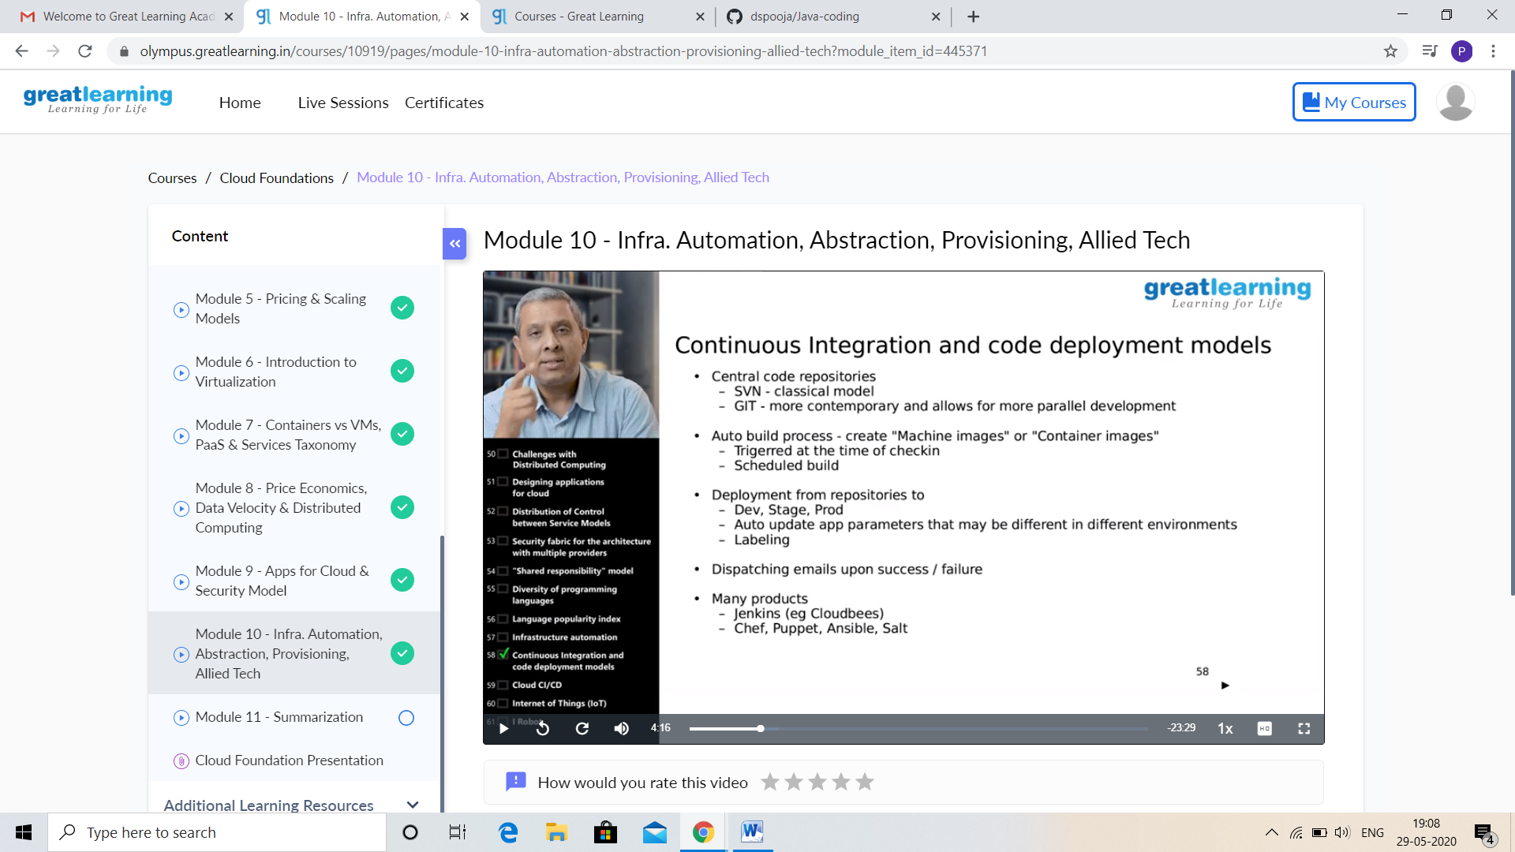

And I attend quiz based on above course, this is my certificate

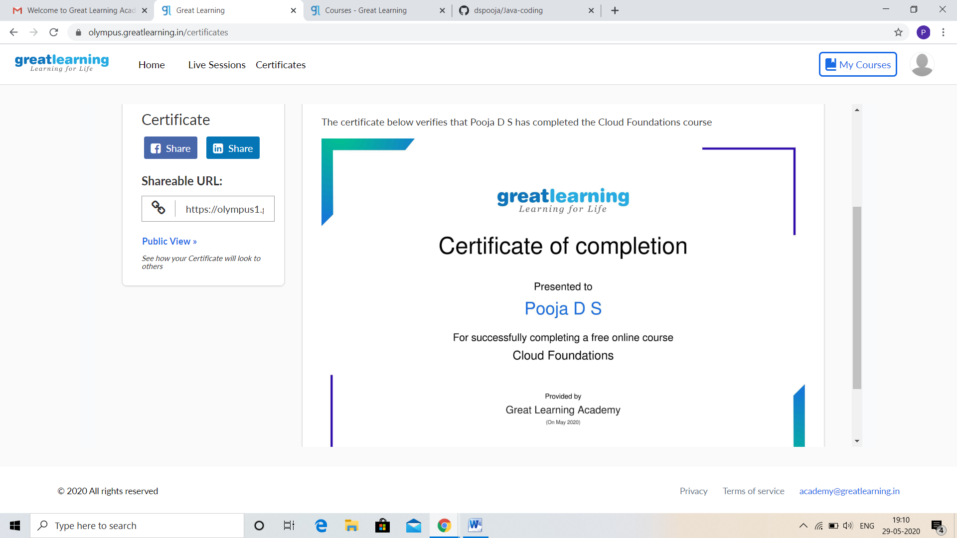

And I continue the next certificate course that is **Introduction to Digital Marketing. Concept of this course is:**

* Consumer Journey of Today
* Explanation of New Medias
* Explanation of New Medias -Contd

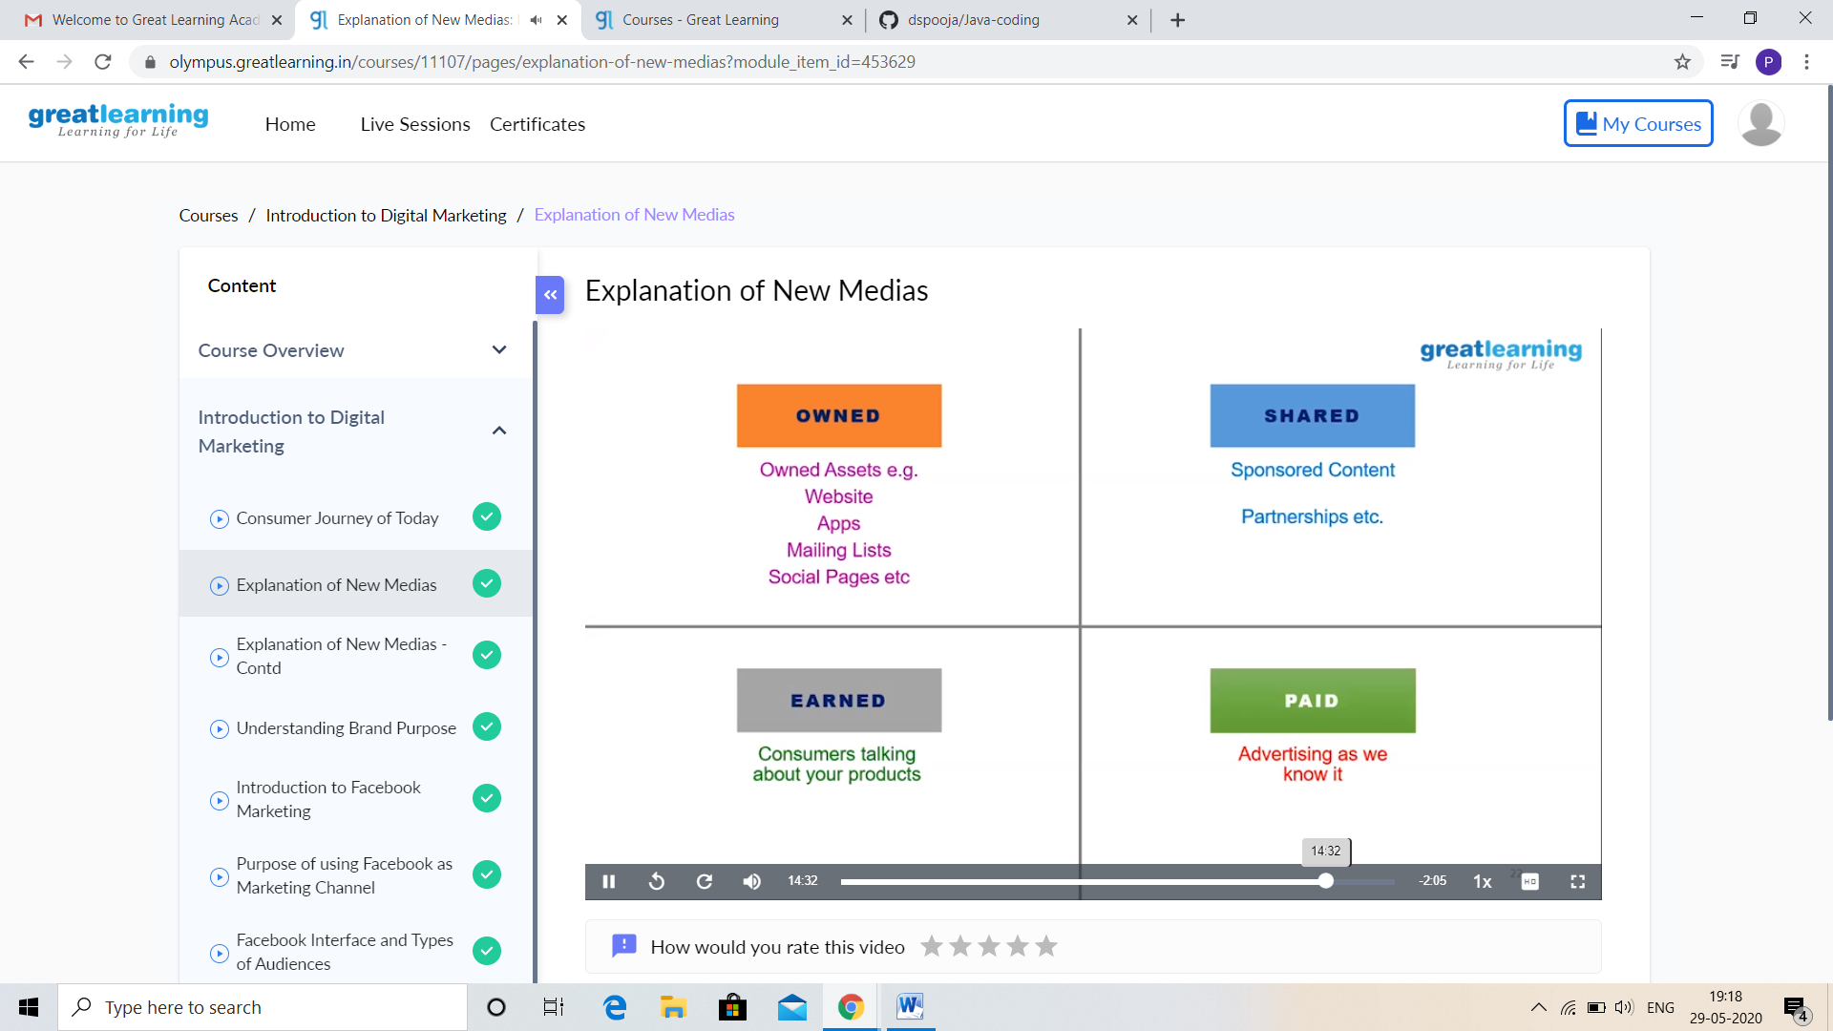

CODING CHALLENGES DETAILS:

Problem statement 1:

Write a Java program to Find size of the largest ‘+’ formed by all ones in a binary matrix.

Given a N X N binary matrix, find the size of the largest ‘+’ formed by all 1s.

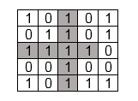

For above matrix, largest ‘+’ would be formed by highlighted part of size 8.

The idea is to maintain four auxiliary matrices left[][], right[][], top[][], bottom[][] to store consecutive 1’s in every direction. For each cell (i, j) in the input matrix, we store below information in these four matrices –

left(i, j) stores maximum number of  
consecutive 1's to the left of cell (i, j)  
including cell (i, j).

right(i, j) stores maximum number of  
consecutive 1's to the right of cell (i, j)  
including cell (i, j).

top(i, j) stores maximum number of  
consecutive 1's at top of cell (i, j)  
including cell (i, j).

bottom(i, j) stores maximum number of  
consecutive 1's at bottom of cell (i, j)  
including cell (i, j).  
After computing value for each cell of above matrices, the largest + would be formed by a cell of input matrix that has maximum value by considering minimum of (left (i, j), right (i, j), top(i, j), bottom(i, j) )

Solution : Uploaded it in github

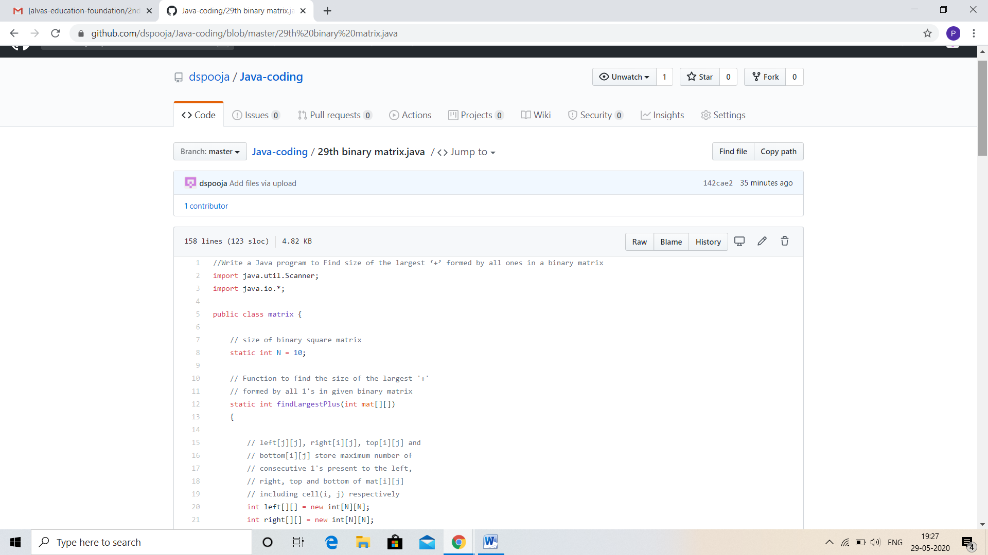

Problem statement 2:

Write a C Program to generate first N Armstrong Numbers

Armstrong number is a number that is equal to the sum of cubes of its digits. For example 0, 1, 153, 370, 371 and 407 are the Armstrong numbers.

Example 1:  
Let's try to understand why 153 is an Armstrong number.  
153 = (111)+(555)+(333)  
where:  
(111)=1  
(555)=125  
(333)=27  
So:  
1+125+27=153

Example 2:  
371 = (333)+(777)+(111)  
where:  
(333)=27  
(777)=343  
(111)=1  
So:  
27+343+1=371

Solution: Uploaded in github.

